**REIMAGINEED**

The Disruptor in AI Education



**Brand Style Guide**

The Right Path Educational Consulting Inc.

Version 2.0 | 2025

Table of Contents

|  |  |
| --- | --- |
| 1. Vision Statement | Page 3 |
| 2. Mission Statement | Page 4 |
| 3. Brand Evolution | Page 5 |
| 4. Thought Leadership | Page 6 |
| 5. Logo System | Page 7 |
| 6. Color Palette | Page 8 |
| 7. Typography System | Page 9 |
| 8. Imagery Guidelines | Page 10 |
| 9. Voice & Tone | Page 11 |
| 10. Visual Language | Page 12 |
| 11. Brand Applications | Page 13 |
| 12. Do's & Don'ts | Page 14 |
| 13. Social Media Guidelines | Page 15 |

Vision Statement



We envision a future where AI empowers every educator and student to reach their full potential, transforming education through innovation, accessibility, and lifelong learning.

Our Vision

ReimagineED is more than a brand—it's a movement. We position Black and Latino educators at the forefront of the AI revolution in education, not as followers, but as pioneering leaders reshaping the future of learning.

Our vision challenges the status quo. We reject the notion that AI in education is something that happens to communities of color. Instead, we envision a future where these communities lead the transformation, bringing unique perspectives, cultural wisdom, and innovative thinking to the forefront of educational technology.

As The Disruptor, we push boundaries of what's possible with technology in classrooms. We make waves by centering marginalized voices in the AI conversation. We refuse safe, comfortable narratives about educational technology.

Core Principles

Disruption as Responsibility

We disrupt because the status quo isn't serving our students. Transformation isn't optional—it's our duty.

Technology as Liberation

AI and tech should remove barriers, not create them. We center equity in every innovation discussion.

Educators as Innovators

Black and Latino educators aren't passive recipients of tech—we're the architects of educational futures.

Mission Statement

Our mission is to empower educators and educational leaders with AI-driven solutions that enhance teaching effectiveness, streamline administrative processes, and create personalized learning experiences for all students.

Three Pillars

Educate

Provide comprehensive AI training and professional development that honors cultural context and practical classroom realities.

Employ

Create career pathways and employment opportunities in AI-enhanced education, ensuring our communities benefit economically from the AI revolution.

Empower

Equip educators with tools and knowledge to transform their practice while maintaining their authentic voice and cultural identity.

Supporting Values

Community as Catalyst

Collective wisdom and shared experience drive our approach. We rise together, learning from each other's successes and challenges.

Excellence Without Exception

We hold ourselves to the highest standards because our communities deserve nothing less. Mediocrity is not an option.

Brand Evolution

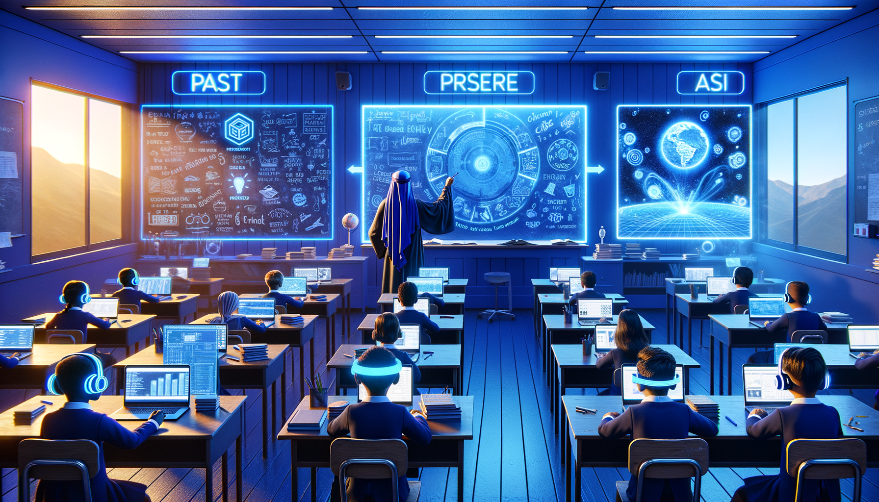

Our brand represents the evolution of education from traditional methods to AI-enhanced learning. We bridge the past, present, and future of education, honoring proven pedagogy while embracing transformative technology.

The Disruptor Archetype

ReimagineED embodies The Disruptor brand archetype. We challenge conventions in how AI is discussed in education. We push boundaries of what's possible with technology in classrooms. We make waves by centering marginalized voices in the AI conversation.

Our Journey

Past

Traditional educational methods served their time but left gaps in equity and accessibility.

Present

AI technology emerges as a transformative force, but without intentional leadership, it risks replicating existing inequities.

Future

ReimagineED leads a movement where Black and Latino educators architect the future of AI-enhanced learning.

Thought Leadership



ReimagineED leads the national conversation on AI in education through podcasts, webinars, speaking engagements, and strategic content. We don't just participate in the discourse—we shape it.

Podcast Format

**Format:** 45-60 minute episodes (edited to 35-45 for pacing)

**Structure:** News roundup → Deep dive → Guest expert → Actionable takeaways

**Production:** High-quality audio with dynamic editing—not static conversation

**Visual:** YouTube video versions with tech-forward motion graphics

Content Pillars

AI Myth Busting

Debunking common misconceptions about AI in education

Educator Spotlights

Showcasing innovators in action across K-12 and higher ed

Tech Tutorials

Practical AI tools for classrooms that teachers can use tomorrow

Industry Analysis

What's happening in ed-tech and why it matters for our communities

Community Conversations

Amplifying educator voices and lived experiences

Platform Strategy

LinkedIn

Thought leadership, professional discourse, superintendent-level engagement

Instagram

Behind-the-scenes, community building, visual quotes

Twitter/X

Real-time commentary, news curation, debate

TikTok

Educational tech tips, myth-busting, accessibility

Logo System

Primary Logo

The ReimagineED logo combines modern typography with tech-forward sensibility. The wordmark uses bold geometric letterforms that convey innovation and authority.



*Primary Logo - Full Color*

Logo Construction

"REIMAGINE" appears in Deep Navy Blue (#0B1D3A), representing authority and technological sophistication. "ED" appears in Breakthrough Gold (#FFD33A), symbolizing innovation and excellence.

Clear Space

Maintain a minimum clear space around the logo equal to the height of the letter 'E' in the wordmark on all sides. This ensures the logo maintains visual impact and isn't crowded by other elements.

Minimum Size

Digital: 120px wide | Print: 1.5 inches wide  
  
Below these sizes, legibility is compromised. For smaller applications, use the abbreviated "RE" mark.

Logo Variations

Full Color

Primary usage on white or light backgrounds

Reversed

White logo on navy or dark backgrounds

Monochrome

Single color for limited production contexts

Brand Color Palette

Primary Colors

|  |  |  |  |
| --- | --- | --- | --- |
| **Color Name** | **Hex** | **RGB** | **Usage** |
| Deep Navy Blue | #0B1D3A | RGB(11, 29, 58) | Authority, intelligence, technological sophistication |
| Breakthrough Gold | #FFD33A | RGB(255, 211, 58) | Innovation, excellence, breakthrough thinking |
| Electric Blue | #00D9FF | RGB(0, 217, 255) | AI, digital transformation, future-forward |

Secondary Colors

Vibrant Purple (#7B2FFF)

Innovation, creativity, disruption

Neon Coral (#FF6B6B)

Energy, action, bold moves

Charcoal (#333333)

Professional depth, technical precision

Gradient System

**Primary Gradient:** Navy → Electric Blue → Gold (tech hero moments)

**Secondary Gradient:** Purple → Coral (innovation emphasis)

**Accent Gradient:** Navy → Purple → Electric Blue (AI-inspired backgrounds)

Typography System

Primary Typeface

Our typography system balances professionalism with tech-forward energy. We use clean, geometric sans-serif fonts that convey innovation while remaining highly readable.

Headlines

Space Grotesk ExtraBold or Arial Bold, 24-36pt  
Bold, geometric letterforms that command attention

Subheadings

Space Grotesk Bold or Arial Bold, 18-20pt  
Clear hierarchy while maintaining visual flow

Body Text

Inter Regular or Arial Regular, 11-12pt  
Optimized for extended reading, 1.4-1.5 line height

Technical Typography

Monospace

Fira Code or Courier New  
Use for technical content, code snippets, and data displays

Typography Hierarchy

Consistent typographic hierarchy ensures content is scannable and accessible:

**Level 1 (Page Titles):** 28-36pt, Bold, Navy

**Level 2 (Section Headers):** 18-20pt, Bold, Electric Blue

**Level 3 (Subsections):** 14-16pt, Bold, Navy

**Body Copy:** 11-12pt, Regular, Charcoal

**Captions/Notes:** 9-10pt, Regular or Italic, Charcoal

Imagery Guidelines

All ReimagineED imagery centers Black and Latino educators as leaders and innovators. Our visual language is tech-forward, dynamic, and authentically representative.

Primary Subjects

**•** Black and Latino educators engaging with AI technology

**•** Futuristic classroom settings with holographic displays

**•** Educators as tech innovators (not just users)

**•** AI-augmented teaching moments

**•** Community collaboration with tech overlay

Visual Style

Lighting

Dramatic, with neon/tech accents (blues, purples, golds)

Composition

Dynamic angles, movement, energy

Treatment

Slight futuristic/sci-fi influence without being fantastical

Authenticity

Real human emotion + tech enhancement

AI Image Generation Prompt Formula

"Professional photograph of [Black/Latino educator demographic] [action] in [futuristic classroom/tech setting], dramatic lighting with [neon blue/purple/gold] accents, tech-forward aesthetic, cinematic composition, authentic human emotion, 8K quality, photorealistic but slightly futuristic, emphasizing innovation and transformation"

Voice & Tone

The ReimagineED voice is unmistakable. We speak with authority earned through expertise and lived experience. Our tone adapts to context while maintaining our core identity.

Voice Characteristics

Bold & Unapologetic

We don't hedge or soften our message. When we have something to say, we say it directly.

Intellectually Rigorous

Grounded in research, not hype. We back our claims with evidence and expertise.

Culturally Authentic

Speaks from and to Black and Latino educator experience. We don't code-switch our identity.

Future-Focused

Always looking ahead, never backwards. Yesterday's solutions don't solve tomorrow's challenges.

Action-Oriented

Disruption requires movement, not just talk. Every piece of content drives toward action.

Tone Guidelines

**DO:** Challenge conventional wisdom, Provoke thought and inspire action, Question assumptions about AI and education, Center community voice in every discussion

**DON'T:** Patronize or oversimplify complex issues, Follow trends blindly, Play it safe with lukewarm takes, Dilute our message for comfort

Example Voice

*"We're not asking permission to lead the AI revolution in education—we're already here."*

Visual Language

Our visual language extends beyond photography to include patterns, icons, and graphic elements that reinforce the ReimagineED identity.

Graphic Elements

Circuit Patterns

Subtle tech-inspired line work suggesting AI/neural networks

Gradient Overlays

Brand color gradients for depth and tech feel

Geometric Shapes

Bold, angular forms representing disruption and innovation

Data Visualization

Clean, modern charts and graphs for research presentation

Icon Style

Icons should be:  
• Geometric and clean-lined  
• 2px stroke weight for consistency  
• Navy or Electric Blue on light backgrounds  
• White or Gold on dark backgrounds  
• Functionally clear before stylistically interesting

Layout Principles

Generous Whitespace

Let content breathe; avoid cluttered layouts

Strong Grid

8-column grid for digital, 12-column for print

Bold Headlines

Headlines should anchor each page/screen

Visual Hierarchy

Clear distinction between content levels

Brand Applications

Consistent brand application builds recognition and trust. These guidelines ensure ReimagineED maintains its distinctive identity across all touchpoints.

Application Guidelines

Podcast Episode Artwork

Navy background, gold accent typography, consistent episode number placement

Social Media Templates

Platform-optimized sizes, brand colors, clear hierarchy

Presentation Decks

Clean layouts, generous whitespace, hero imagery

Email Newsletters

Mobile-first design, scannable format, clear CTAs

Website Elements

Responsive design, accessibility-first, fast loading

Event Materials

Print-ready formats, QR codes for digital connection

Digital Specifications

Website

Responsive design, accessibility-first, maximum 3-second load time

Email

600px max width, inline CSS, mobile-optimized

Social Images

1200×630px (link preview), 1080×1080px (Instagram square)

Video

16:9 aspect ratio, brand intro/outro templates, captions required

Do's & Don'ts

Maintaining brand integrity requires consistent application. These guidelines protect the ReimagineED identity across all uses.

Logo Usage

DO

• Use approved logo files from the brand asset library  
• Maintain minimum clear space requirements  
• Use appropriate color variations for backgrounds  
• Scale proportionally (lock aspect ratio)

DON'T

• Stretch, skew, or distort the logo  
• Change logo colors outside approved palette  
• Add effects (shadows, glows, outlines)  
• Place on busy backgrounds that reduce legibility  
• Recreate or modify the logo in any way

Color Usage

DO

• Use primary colors for key brand moments  
• Apply gradients for tech-forward contexts  
• Ensure sufficient contrast for accessibility

DON'T

• Use colors at reduced opacity except for approved overlays  
• Mix brand colors with non-approved palettes  
• Sacrifice legibility for visual effect

Social Media Guidelines

ReimagineED maintains an active social presence across platforms. Each channel serves a specific purpose in our content ecosystem.

LinkedIn: Thought leadership hub

**•** Long-form articles on AI in education

**•** Research highlights and data insights

**•** Professional discourse and superintendent engagement

**•** Event announcements and recaps

Instagram: Community & culture

**•** Behind-the-scenes content

**•** Visual quotes and key takeaways

**•** Educator spotlights (Stories & Reels)

**•** Event coverage and community moments

Twitter/X: Real-time engagement

**•** Breaking news and commentary

**•** Thread-based deep dives

**•** Live event coverage

**•** Industry debate and discussion

TikTok: Accessible education

**•** Quick AI tips for educators

**•** Myth-busting content

**•** Trending audio with brand spin

**•** Student-facing content